Inner class Lab

Q 2   
  
Write a program to demonstrate the knowledge of students in basic Java  
concepts. Eg., Write a program to read the First name and Last name of a  
person, his weight and height using command line arguments. Calculate  
the BMI Index which is defined as the individual's body mass divided by  
the square of their height

Solution

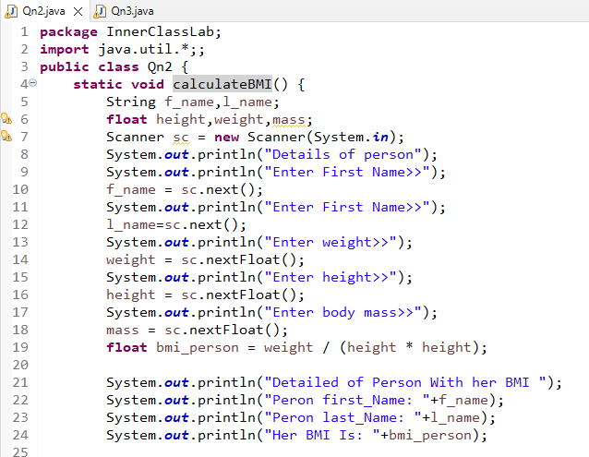

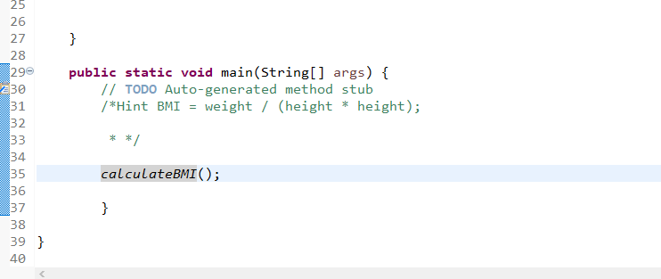

Output

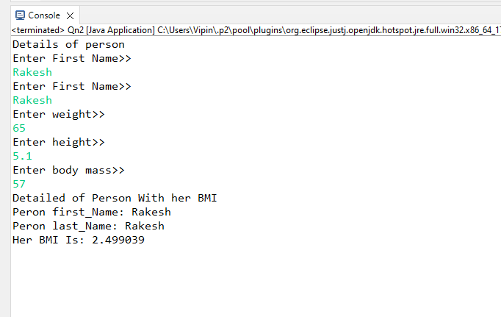

Q 3 wap to ask full name of a person from user in string .  
  
Input Amit Kumar Sharma  
  
  
output first name Amit  
  
middle name        Kumar  
last name=           Sharma

Solution & Output

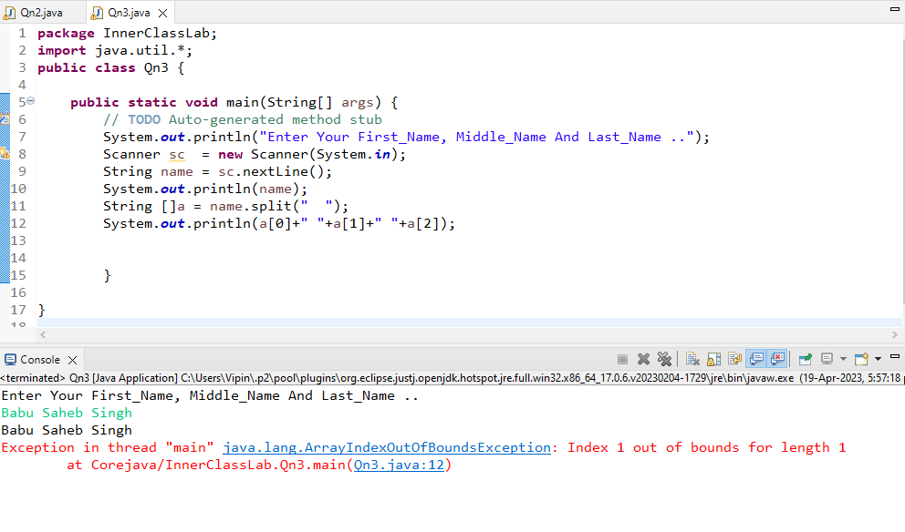

Q 1 Create a class Training having fields like studentid, name ,address,phone.  
  
create two inner classes online training and offline training  
  
In online training define fields like duration,  online marks.  
  
  
a) define get  
  
Data and showData method of same class  
  
In offline training define fields like boolean system allocation,offline marks.  
  
a) Define input and display methods in same class  
  
  
Create main method in Training class and show menu  
   
1) offline training  
  
  
2) online training  
  
Ask choice from user and accordingly call its method.

Solution

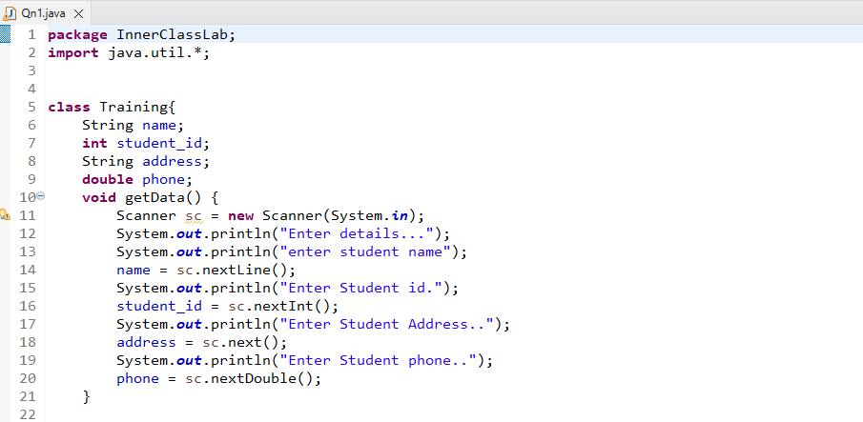

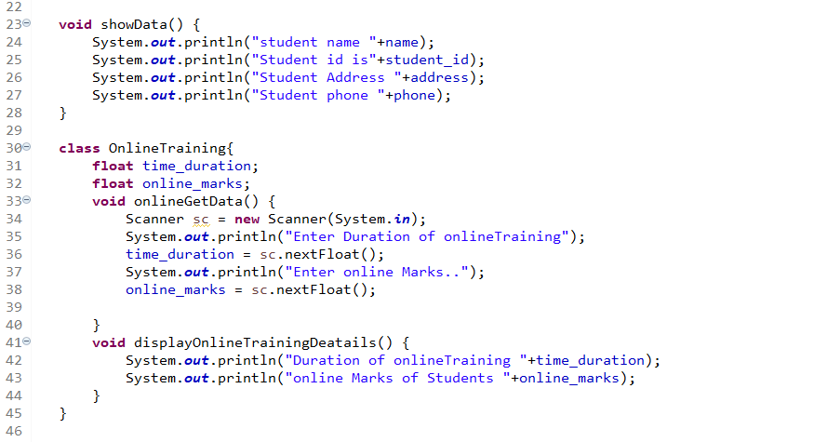

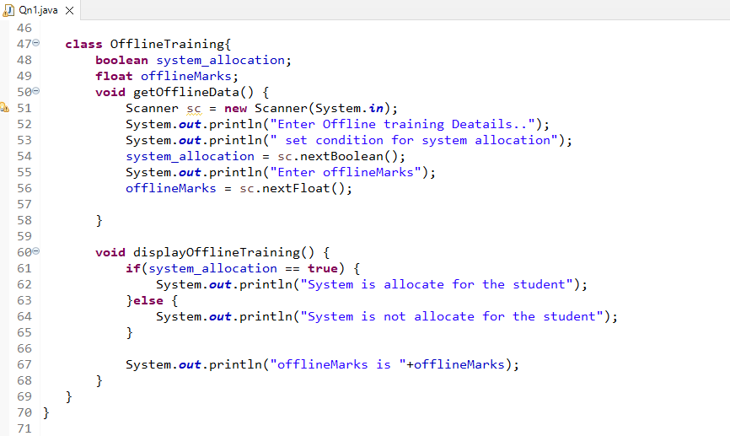

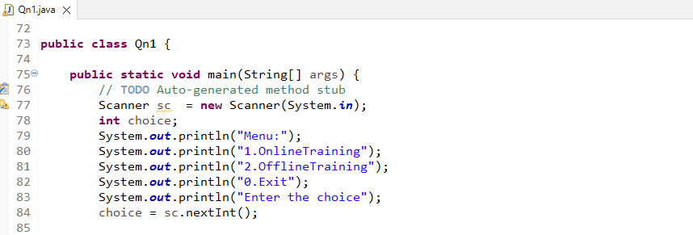

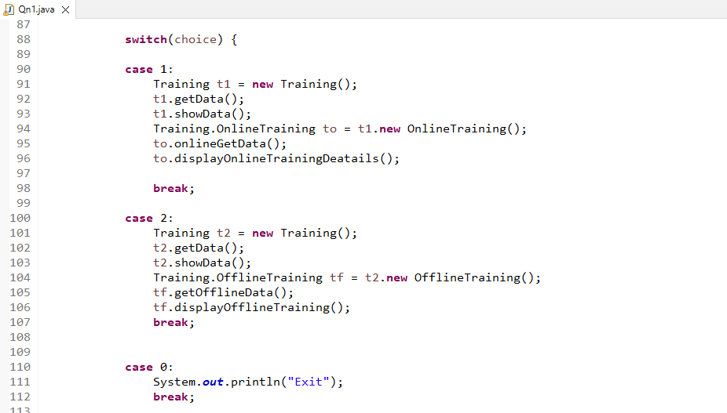

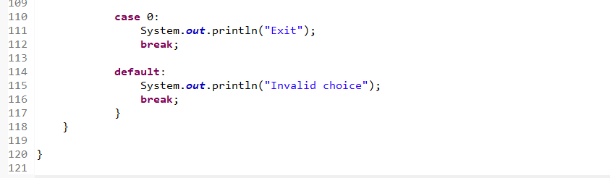

Output

